PRESS RELEASE
THE TELEGÄRTNER WORLD IS GROWING - DISCOVER NEW APPLICATIONS AND PRODUCT SOLUTIONS

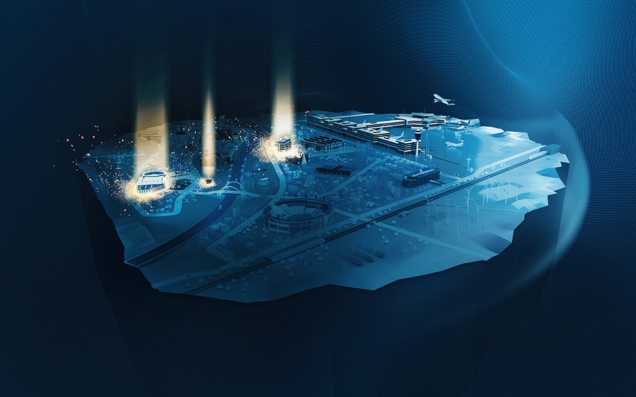
Telegärtner’s virtual World with new applications.

Telegärtner's virtual theme world will be enlarged by two attractions. From May 2021, modern cabling solutions and product information will be presented interactively in two new application areas – School and Residential.

Stuttgart, 5th May 2021 – In November 2020, Telegärtner products and application examples could be explored online and interactively in a three-dimensional world for the first time. With the virtual world, Telegärtner wants to present product information realistically and in an impressive way and make it tangible.

With the new application areas, Telegärtner wants to present further product solutions digitally as well as realistically. Visitors can inform themselves about products and solutions in a playful way. With the expansion of the Telegärtner World, the experience factor is to be increased even further.
The focus in the second release is on structured building cabling in order to be able to present solutions for the increasing demand for high-quality network technology. The new application areas can be visited from May 5, 2021. At the beginning, visitors can expect a spectacular light show. Afterwards, all applications and product information can be explored at any time in a realistic, virtual environment. New to discover are the residential and school areas, but there are also further additions to the existing applications - Office and Antenna. A highlight of the Telegärtner World will be IT cabling and network solutions for schools. Telegärtner will present a variety of solutions to help shaping and pushing digitalization in schools.

The theme world is permanently online and can be visited at any time since November 24, 2020.

Explore our product solutions and inform yourself at: https://www.telegaertner.com/tgworld

Telegärtner was founded in 1945 and is an international full-service provider for professional solutions in telecommunication and data communication technology. Today it is one of the most important manufacturers in its field. The traditional family business is already in the third generation of management. With around 660 employees worldwide, the group generates annual sales up to 100 million euros.

Press contact project team
Telegärtner Karl Gärtner GmbH
Franziska Horwath, Laura König
Lerchenstraße 35
71144 Steinenbronn
marketing@telegaertner.com
Tel.: 07157 125 - 5287
www.telegaertner.com

